|  |
| --- |
|  |

**Texas Tech University**

**ISQS 6350 - Group Project**

**Group 3**

|  |  |
| --- | --- |
| Guyana Census  (working title)  Assessments and Conclusions using R  John Hale  Larry Clinton  Introduction  Guyana is the poorest and least developed country in South America. Half of a tale of two stories - Earning its independence from Britain the same year as Singapore in 1966, Guyana is a land stuck in time where kids go to school in dugout canoes, electricity is from diesel generators, and there is no running water.  That is all about to change. Partnering with ExxonMobil, one of the world’s largest offshore oil discoveries will begin production starting this month.  With GDP expected to increase 1000% in the 10 next years, it would be interesting to see what demographic and industry correlations currently exist that could highlight potential investment opportunities.  The Data  2012 Census data originating from Bureau of Statistics. The data contains information pertaining to 685,668 individuals. Information received includes, region # (state), village name (city), gender, ethnicity, age, religion, and industry. The aggregate data was scaled as a proportion to the population of region. There there are ten regions in Guyana. Most of our analysis will use industry data. | **Fall 2019** |

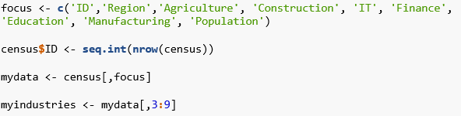

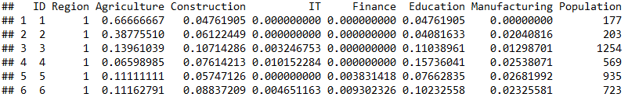

Dimension Reduction Analysis

Cluster Analysis

Confirmatory Factor Analysis (CFA)

Conclusion

Sources:

*Bureau of Statistics, Guyana*

Census Data 2012

<https://statisticsguyana.gov.gy/>

*The $20 Billion Question for Guyana*

Clifford Krauss

July 20, 2018

<https://www.nytimes.com/2018/07/20/business/energy-environment/the-20-billion-question-for-guyana.html>

Cover template from Inter Development Bank (IDB)

[link](https://i1.rgstatic.net/publication/297677347_Guyana's_PetroCaribe_Rice_Compensation_Scheme_Has_Ended_Assessment_and_Policy_Implications/links/56e0279108aee77a15fe8c01/largepreview.png)

ExxonMobil Guyana

<https://corporate.exxonmobil.com/en/Locations/Guyana/Guyana-project-overview>